**ENGINEERING TEAM PROJECT**



PROPOSAL

***Automatic Sea-Trash Collector***

BY

**GROUP 14**

|  |  |  |
| --- | --- | --- |
| NO. | NAME | ID |
| 1 | Kerishmaa Theavy Kunalan | 24488 |
| 2 | Muhammad Fikri Bin Md Nazri | 24448 |
| 3 | Sofea Fariesya Binti Hasnul | 24655 |
| 4 | Yap Hong Yi | 24347 |
| 5 | Kelvin Koh Kai Wen | 24830 |
| 6 | Firdaus Hafizuddin Bin Mohd Fadzil | 24385 |

**Supervisor:**

***Dr Lam Man Kee***

May 2019

Universiti Teknologi PETRONAS  
Bandar Seri Iskandar  
32610 Seri Iskandar  
Perak Darul Ridzuan

**ACKNOWLEDGEMENT**

The beginning of this project was very tough where all we had to think brain-storm the ideas but each of the team members is very committed to achieve our goal together. Every member shared their knowledge from different engineering backgrounds and the effective communication between members has made this project a successful one.

We would like to express our gratitude towards our Engineering Team Project (ETP) supervisor, Dr. Lam Man Kee from Chemical Engineering Department for his support and supervision throughout the process. We received a lot of advice on how to improve our project in many aspects, from the early stages of brainstorming up until the project submission and presentation. We have gained a lot of knowledge from him that will greatly benefit us in the future. Hereby, we would like to express our deepest appreciation again to Dr. Lam Man Kee.

Lastly, we would also want to extend our thank you wishes to Dr. Hilmi, Dr. Nabihah, Dr. Mazli and Dr Azlan for their hard work as the ETP coordinators. The briefing for ETP in the early of semester helped us focus on meaningful topics and developing effective ideas.

**EXECUTIVE SUMMARY/ ABSTRACT**

We identified problems such as water pollution that is caused by dumping of rubbish in to the sea. As we all know, some of the trash in the sea is quite difficult to be clean by humans. Although there are some devices created to reduce this problem, the product are very huge, expensive and also it capture the marine life that come into contact with it. Therefore our prototype is designed to collect the rubbish in the most cost-effective way. A basic explanation of how our prototype works is that the camera detects the trash where the information is then analysed by the Arduino which then makes the motor to lift the net to collect the trash. This idea was inspired by a normal recycle bin that is being used widely around the world. This prototype can help to reduce the waste without using man-power. Moreover, it also differentiates rubbish and non-rubbish items. The results that we portrayed in this are percentage of image recognition by the Arduino. Basically, the Arduino could scan 600 types of trash. We believe this prototype could solve the trash issue in the sea where it also reduce the harm towards the marine life. For further improvement to encounter the usage of this prototype in the future, lifting of the net can be replaced by suction pump where the trash will be sucked in it. Other than that, the prototype also could be improved by applying another sensor where the trash can be separated into recycle and non-recycle items.

# Table of Contents

Table of Contents 2

1.0 INTRODUCTION 3

1.1 Background Analysis 3

1.2 Objective 5

1.3 Project Objectives 5

1.4 Problem Statement 5

2.0 DESIGN THINKING 6

2.1 Literature Review 6

2.2 Design Thinking Tools 11

3.0 DESIGNING 17

3.1 Justification of Design 17

3.2 Alternative Design Concepts 18

4.0 PROJECT MANAGEMENT 20

4.1 Task Allocation and Activities 20

4.2 Schedule/Gantt Chart 21

4.3 Feasibility of Plan 23

5.0 METHODOLOGY 24

5.1 Project Workflow 24

5.2 Identification of Suitable Tools 25

5.3 Justification of Fabrication Choices 26

6.0 ECONOMICAL/ BUSINESS CONSIDERATION 28

6.1 Capital Cost Consideration 28

6.2 Operational Cost Consideration 28

6.3 Alternatives in Materials 29

7.0 CONCLUSION 30

**1.0 Introduction**

**1.1 Background of Project Work**

In these modern days, water pollution had become a major problem around the world. Water pollution is the contamination of water bodies usually caused by human activities and production. Some of the cause of water pollution are improper discharge of chemical from factories, use of toxic chemical for plant and oil spills. But the main cause of water pollution is the improper or excessive discharge of trash such as plastic, glass and other foreign material to the sea or river. Based on Sharpmead, P., Anish, & Simmons, T. (2019, February 09), it is shown that Americans generate 10.5 million tons of PLASTIC waste a year but recycle only 1 or 2 % of it. An estimated of 14 billion pounds of trash is dumped in the world's oceans every year. The United Nations Environment Program estimates there could be as many as 51 trillion micro plastic particles in the oceans already. Throwing of rubbish into the sea causes a lot of problem to the environment and also will affect the ecosystem.

The problem caused by throwing trash or rubbish into the sea is endangering the marine species and ecosystem. Based on McGrath, M. (2018, September 13), one of the most affected species are the turtles as the turtles had mistaken plastic bag for a jellyfish which is their main food source, so this will confuse them to consume the plastic and causes them to choke or having digestive problem. This is because plastic is petroleum based and does not digest, so it will cause blockage in their digestive system and eventually death. Birds are also affected by the improper waste of trash, birds that is living near the ocean and river always got caught up in the debris and end up suffocating and finally dying. Disposal of rubbish into the ocean does not only affect the animal ecosystem, it will also affect the human being in different ways. In addition to polluted marine animals, the ingestion of plastic materials by the fish and many marine animals also in-turn causes harm to people who consume it. So this can be conclude that throwing of rubbish into the ocean causes a lot problem.

A few solutions had been carried out to reduce the problem of disposal of rubbish into the ocean. Some of them are by reducing and recycling the trash at the beach which is by using man power. Although it had been done around the world, the amount of trash lingering in the ocean still cease to decrease. Based on Voa, & Voa. (2018), some engineers had even created a huge device to gather trash floating in the Pacific Ocean between California and Hawaii. The device consists of a ship pulling the pipe-shaped floating barrier which will collect all the garbage it had found in the ocean. Although it is very efficient, it requires a very high cost to operate and some countries does not have the sufficient fund to operate it. That is why a lot of alternative is required to reduce the amount of trash in the ocean in order to prevent water pollution.

**1.2 IDENTIFICATION AND DEFINITION OF PROBLEM**

Based on our project, a few problems had been found. Some of the problems:

* Trash had become the main cause in polluting the sea and it is affecting the habitat and ecosystem of the marine animals
* To reduce the usage of man-power in cleaning the trash in the sea
* Some trash is hard to be collected and recycled as it is unreachable and floating in hard reached places
* Underdeveloped countries or rural area are having a hard time collecting the garbage in the sea
* Hard to maintain the cleanliness of the sea only by man power.

**1.3 OBJECTIVE AND SCOPE**

The main aim of the project is to easily collect the trash and rubbish that is still lingering in the ocean and cannot be reach by human to reduce the amount of trash in the ocean without requiring high cost and energy to operate.

Automatic Sea- Trash collector is aimed to tackle several issues that have been identified via research and observations. This project aims to:

* To reduce the amount of plastic which is floating near the boats, shipyard, off-shore platform
* Reduce water pollution and helps to stabilize the ecosystem
* To reduce the man power needed in reducing the amount of trash in the sea and also maintaining the ecosystem
* Helps underdeveloped country to reduce the amount of trash in the sea without having to spend a lot of funding.

**1.4 Literature Review**

Upon entering the year 2020, the amount of trashes being dumped into the ocean has been rapidly increasing linearly with time. Marine trash which includes plastics, wood, metal, paper and other manufactured things are found worldwide and at all depths of the ocean. It has been estimated around 80 percent of the marine trash originate from the land and another 20 percent from sea vessels as stated by the US Department of Commerce. Although most of the countries already started to spread the awareness and campaigning to prevent more waste being dumped, this amount of massive number of trash hardly decrease. This situation is extremely dangerous to the marine animals as they will keep encounter the waste everywhere. The main problem is some trashes are taking way too long time to decompose especially plastics which takes hundreds of year amount of time. During this period, some of the waste stay in perfect and original shape while some already being decomposed into tiny particles. These tiny particles might harm the marine lives as when they eat the plastic hence this will cause indigestion that leads to death. Other situation is marine animals entangle with the trash which causes starving, suffocation and drowning.

According to United Nations, around 800 species is being greatly affected by the marine trash and 80 percent of it is because of plastic litter as stated by Reddy, S. (2018). Throughout the year, there are many cases where animals were found dead with their stomach full of trash such as turtles, birds and whales. Micro-plastics (less than 5mm) also absorbs toxic chemical which can produce the effect of animals having cancers and weaken the immune system as well as exposed to other diseases. This already prove that undecomposed trash that adds up over the years is a crucial problem to the marine lives. Figure 1 below shows the top marine trash items found in the cleanups over the last 25 years which refer to an article titled Trash Pollution. (n.d.)

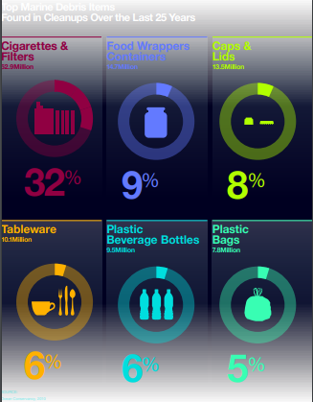

Figure 1: Items Found in the Cleanup

The data shows Cigarettes & Filters with 52.9 mil, Food Wrappers and Containers with 14.7 mil, Caps & Lids with 13.5 mil, Tableware with 10.1 mil, Plastic Beverages Bottles with 9.5 mil and Plastic Bags with 7.5 mil.

In order to solve this problem, the proposed solution is by using an Automatic Sea - Trash Collector. By using this machine, the trashes that passes through it will be automatically collected and sorted as rubbish or non-rubbish object. When the items are classified as rubbish, it will automatically capture by a net and put into a special container/bin next to it. This idea was inspired by a normal recycle bin that is being widely used all around the world as shown in the Figure 2 below. From this topic, we found some articles regarding machine learning to classify the trash on the internet thus we use the idea to detect the rubbish and non-rubbish object by using a camera. Our proposed automatic trash collector machine will collect all classified trash items then put it in one place. As stated by Silva, A.F. and Eduardo A.S. (2018), waste management and efficient sorting of them have been considered as an important role for ecologically sustainable development worldwide and it is essential for the society to reduce waste accumulation by recycling and re-using disposed of products.

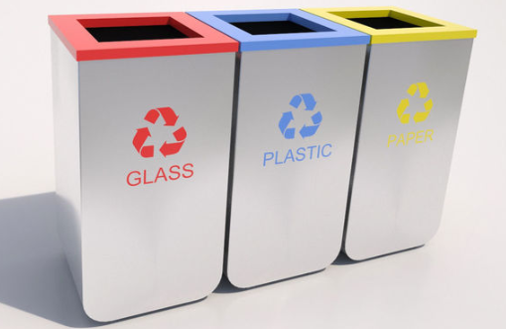

Figure 2: Recycle Bin

The main advantage of using the Automatic Sea – Trash Collector is it can really help to reduce the number of trashes in the ocean without any manpower needed. Furthermore, the machine is eco-friendly and does not produce any other additional pollution. Lastly, the machine is smart where it can differentiate between the rubbish and non-rubbish object.

The application of this automatic machine has a great potential in reducing the current major problem regarding sea trash if it is being implanted in top countries that mismanaged plastic waste disposed in oceans shown in Figure 3 below which refer to an article titled Plastic Statistics. (2018) Thus, we strongly believe that this machine can be used in the industry as a new innovation for the betterment of our future. In order to achieve the goal, this proposed design will be further improved in order to meet the economic perspective so that the usage can be implemented everywhere around the world with a suitable design and at a more affordable price.

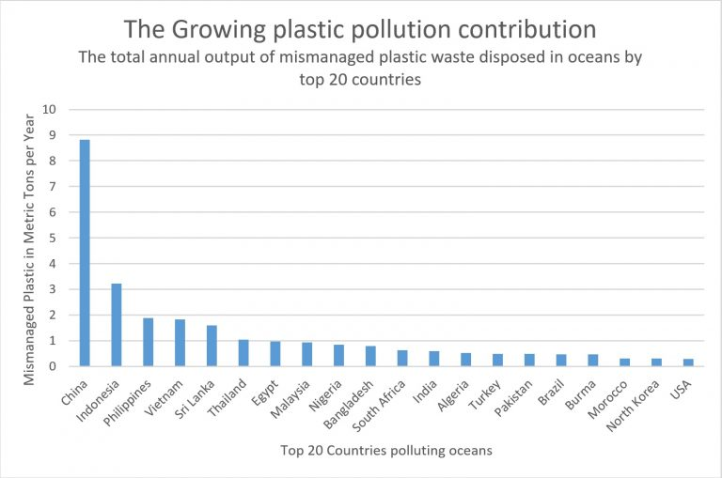

Figure 3: Statistics of Growing Plastic Pollution Contribution by Countries

**2.0 PROJECT MANAGEMENT**

**2.1 Task Listing & Distribution**

**2.2 Progress monitoring (Gantt Chart)**

|  |  |  |  |  |  |  |  |  |  |  |  |  |  |
| --- | --- | --- | --- | --- | --- | --- | --- | --- | --- | --- | --- | --- | --- |
| **Task** | **Activities** | **May** | | | **June** | | | | **July** | | | | **August** |
| **W1** | **W2** | **W3** | **W4** | **W5** | **W6** | **W7** | **W8** | **W9** | **W10** | **W11** | **W12** |
| **PROJECT STARTUP /**  **CONCEPT DESIGN** | Ice breaking among team members |  |  |  |  |  |  |  |  |  |  |  |  |
| Brainstorming ideas |  |  |  |  |  |  |  |  |  |  |  |  |
| Consultation with supervisor |  |  |  |  |  |  |  |  |  |  |  |  |
| Rating ideas according to criteria |  |  |  |  |  |  |  |  |  |  |  |  |
| Finalize the project decision |  |  |  |  |  |  |  |  |  |  |  |  |
| **PROJECT PROPOSAL** | Research on project |  |  |  |  |  |  |  |  |  |  |  |  |
| Data collection, Analyze survey result |  |  |  |  |  |  |  |  |  |  |  |  |
| First draft |  |  |  |  |  |  |  |  |  |  |  |  |
| Edit draft, Finalize project proposal |  |  |  |  |  |  |  |  |  |  |  |  |
| 14/6 – Submission of Project Proposal |  |  |  |  |  |  |  |  |  |  |  |  |
| **DETAIL DESIGN** | Mechanical design, Research, Draft sketching of working prototype |  |  |  |  |  |  |  |  |  |  |  |  |
| Structural drawing (AutoCad & Catia) |  |  |  |  |  |  |  |  |  |  |  |  |
| **MARKET RESEARCH** | Survey on the cost of materials needed, Economic analysis |  |  |  |  |  |  |  |  |  |  |  |  |
| Collect & Purchase materials |  |  |  |  |  |  |  |  |  |  |  |  |
| Collect mechanical component |  |  |  |  |  |  |  |  |  |  |  |  |

|  |  |  |  |  |  |  |  |  |  |  |  |  |  |
| --- | --- | --- | --- | --- | --- | --- | --- | --- | --- | --- | --- | --- | --- |
| **Task** | **Activities** | **May** | | | **June** | | | | **July** | | | | **August** |
| **W1** | **W2** | **W3** | **W4** | **W5** | **W6** | **W7** | **W8** | **W9** | **W10** | **W11** | **W12** |
| **DEVELOPMENT OF PROTOTYPE** | 10/07 – Submission of Form 03 |  |  |  |  |  |  |  |  |  |  |  |  |
| Fabrication of the system |  |  |  |  |  |  |  |  |  |  |  |  |
| Program the Arduino set |  |  |  |  |  |  |  |  |  |  |  |  |
| Test the program |  |  |  |  |  |  |  |  |  |  |  |  |
| Assemble all parts |  |  |  |  |  |  |  |  |  |  |  |  |
| Run a full test |  |  |  |  |  |  |  |  |  |  |  |  |
| Complete prototype |  |  |  |  |  |  |  |  |  |  |  |  |
| 12/07 – Evaluation on Fabrication |  |  |  |  |  |  |  |  |  |  |  |  |
| **POSTER PRESENTATION**  **& DEMO**  **(PRE-SEDEX)** | Poster preparation |  |  |  |  |  |  |  |  |  |  |  |  |
| 19/07 – PRE-SEDEX Exhibition,  Product Demo & Presentation Assessment |  |  |  |  |  |  |  |  |  |  |  |  |
| **FINAL REPORT** | Discussion, first and second draft |  |  |  |  |  |  |  |  |  |  |  |  |
| 26/07 – Submission of Claim Breakdown Form & Receipts |  |  |  |  |  |  |  |  |  |  |  |  |
| Edit draft, Finalize final report |  |  |  |  |  |  |  |  |  |  |  |  |
| 26/07 – Submission of Peer Evaluation Form |  |  |  |  |  |  |  |  |  |  |  |  |
| 26/07 – Submission of Final Report |  |  |  |  |  |  |  |  |  |  |  |  |
| 26/07 – Return Prototype |  |  |  |  |  |  |  |  |  |  |  |  |

Process of the Task Deadline

**3.0 PROCEDURE AND ANALYSIS**

**3.1 Application of Design Thinking**

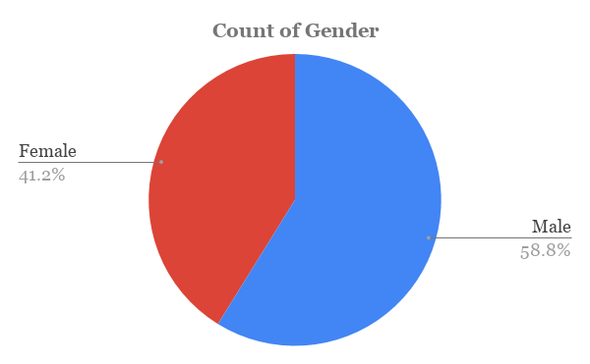

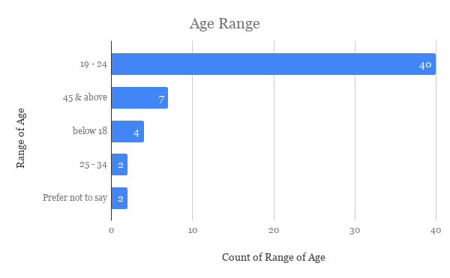

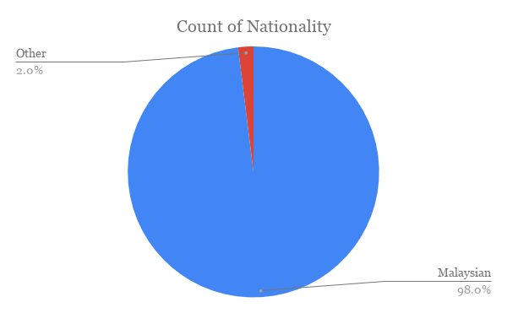

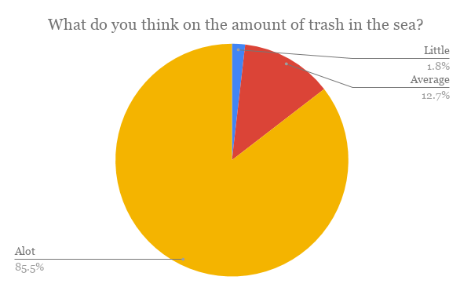

What do you think we can do to save marine lives?

|  |
| --- |
| Collect the trash from the sea |
| Reduce the trash in the sea |
| Reducing the use of plastics |
| Lessen the usage of plastics in day to day life |
| Doing the best that I can |
| Stop the usage of plastic |
| Encourage people to throw their litter correctly |
| Throw less rubbish |
| Don’t throw rubbish at the ocean |
| Be a civilised person and don't throw rubbish to sea |
| Reduce plastic waste |
| collect the sea trash |
| Reduce plastic use and plastic pollution |
| Do not leave rubbish when leaving from the beach. Pick up rubbish instead |
| Keep the sea clean |
| Educate the public |
| Metal straw |
| Stop producing of plastic and find new alternatives |

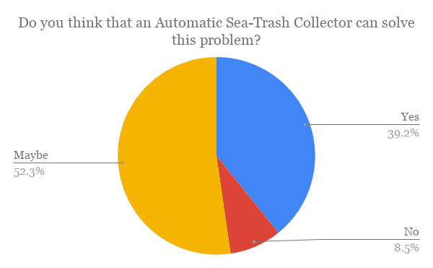

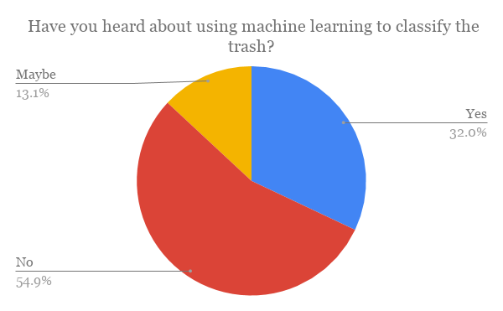

From the survey that we did regarding the Automatic Sea-Trash Collector, we managed to get 146 responses from different categories of gender, nationality and range of age. From the results, around 61% of them are male and 39% are female. In terms of nationality, 97.9% are Malaysian and another 2.1% are non-Malaysian which are Israel and Pakistan. In addition, around 45.9% are in the range of 19-24 years old where they are in the major group while 32.2% are categorized in the age of 45 and above.

The first question asking about their opinion on the amount of trash in the sea and 82.9% of the responders stated that there is a lot of trash, 14.4% stated average and 2.7% stated little amount of trash. This shows that most of them are aware about the real condition of the pollution in the ocean that is happening right now. Next question is about the effects of the trash to the sea creatures. About 76.7% chose the sea creatures might consume the trash, 72.6% loss of habitat, 70.5% chose extinction of sea creatures, 63.7% chose affect the tourism spot and the plants live inside the sea would not receive enough sunlight and lastly around 59.6% chose food supply for humans will be contaminated. This proves that the massive amount of trash in the ocean will eventually produce such negative effects to all living things either animals, plants and humans. Furthermore, this matter will lead to the imbalance of eco-system in the future because the water source and food supply from the ocean are already polluted.

The responders also gave some good ideas on how to save the marine life. The major common ideas are awareness campaign and go green program where the big part is to create awareness to the community so that they know about the real situation that is happening. If this matter always being ignored and neglected, more negative effects will arise in the future. Next is not throwing rubbish into the sea and avoid the usage of plastics in daily life. Lastly, the law enforcement must be tighten and strengthen so that less people will keep throwing the rubbish into the sea.

From 146 responders, 52.7% stated that this Automatic Sea – Trash Collector ‘maybe’ can solve this problem, 38.4% stated yes while 8.9% stated no. For the last question, 53.4% has not heard about using machine learning to classify the trash, 32.9% has heard about it and 13.7% stated maybe. Throughout the survey, it can be summarized that most people now about the current situation which is there is a massive amount of trash being dumped into the sea every single day. They also agreed that this machine could help to reduce the amount of trash so that this problem can be solved eventually. Therefore, it is important for us to implant the usage of Automatic Sea – Trash Collector so that all those negative effects can be avoided and hopefully can create a better environment for the sea creatures as well as a more balanced ecosystem to all living things in the world.

**3.2 Methodology**

**3.3 Fundamental Engineering Analysis**

**4.0 BUSINESS/ ECONOMIC ANALYSIS**

**4.1 Capital Cost Consideration**

Capital cost is the expenses required in constructing the prototype to be fully functioning. Regarding Engineering Team Project (ETP), UTP has allocated a grand total of RM300 per team. Following is the estimated budget for this project:

*Table 4.1.1 : Estimated Cost Components for Automatic Sea-Trash Collector*

|  |  |  |  |  |
| --- | --- | --- | --- | --- |
| **No** | **Item** | **Quantity** | **Price Per Item (RM)** | **Total (RM)** |
| 1 | Plastic Mesh (Net) 0.25m | 1 | 2.00 | 2.00 |
| 2 | 2 x 18650 Battery Holder | 1 | 2.70 | 2.70 |
| 3 | 3.7V 2000mAh Li-Ion Battery | 2 | 10.00 | 20.00 |
| 4 | Maker Drive: Simplifying H-Bridge Motor Driver | 1 | 14.90 | 14.90 |
| 5 | 6V 85RPM DC Micro Metal Gearmotor | 2 | 18.50 | 37.00 |
| 6 | HD 720p Webcam | 1 | 99.00 | 99.00 |
| 7 | Polystyrene Box | 1 | 9.00 | 9.00 |
| 8 | L-Bracket | 5 | 2.50 | 12.50 |
| **GRAND TOTAL** | | | | **199.60** |

* 1. **Customer Base**

The Automatic Sea Trash Collector focuses on spreading its possibilities among offshore establishments in supporting the nation’s effort to reduce amount of waste floating at the sea. For instance, our prototype may be attached to existing oil platform while the production continues, this device will assist in maintaining a clean ecosystem nearby. As for coastal areas, suggestions have been made to place our device at accessible harbour.

* 1. **Competition & Potential Market**

**Competitive Advantages**

After thorough discussions and researches made by team members, we have collectively decided to proceed with this project due to few extra edges predicted regarding our idea. As common as the theme of this prototype may be, our project dedicates this innovation in a smaller scale which gives us an advantage in breaking our way through the market while contributing towards a noble cause. Unlike the current sea trash collector developed by Netherland’s Ocean Clean Up Project which requires approximately $7 million USD, our very own Automatic Sea Trash Collector may appeal to local offshore facilities because it restricts such high demand financially. Although it may not create a huge impact in waste reduction in the near future but this device will bring a significant changes to the sanctity of Malaysian waters in the long run.

**Product Pricing**

|  |  |
| --- | --- |
| **ITEMS/MATERIALS** | **PRICE (RM)** |
| Plastic Mesh (Net) | 0.40 |
| Maker Drive | 11.92 |
| 6V DC Micro Metal Gear-motor | 16.00 |
| 720p HD Webcam | 79.20 |
| L-Bracket | 4.00 |
| Metal Stick for Camera | 10.32 |
| Arduino Uno | 12.00 |
| Workmanship | 5.00 |
| **Total Price per Unit** | **138.84** |

*Table 4.3.1: Items & Materials Price List for Mass Production of Prototype*

Several apparent changes are displayed in Mass Production table from Estimated Values of Cost Components for Prototype table. Firstly, Battery and Battery Holder are removed from marketable cost calculation due to this device will be utilising electricity from the nearby facility which will further lengthen the span of lifetime for this device compared to powered by battery that demands frequent replacements over time. Next, polystyrene box used in prototype construction serves as a sole purpose of illustrating the conditions of sea hence why it is no longer included in this section.

In calculating the total cost of producing a single unit of Automatic Sea Trash Collector, we have considered in reducing the initial cost of prototype fabrication with regards to bulk orders concept by a weightage of 20%. The calculation above has also included workmanship required to install and build this device which does not require a complicated setup. Hence, the total cost of purchasing will be **RM 138.84** available to the consumers.

* 1. **Operational Cost Consideration**

The prototype requires frequent maintenance over a certain period of time. Listed below are the details of running cost:

*Table 4.4.1 : Estimated Operational Cost of Automatic Sea-Trash Collector (Monthly)*

|  |  |  |
| --- | --- | --- |
| **No** | **Operations** | **Total (RM)** |
| 1 | Electric Power Supply | 20.00 |
| 2 | Cleaning | 5.00 |
| 3 | Operating Staff | 0.00 |
| 4 | Insurance and Taxes | 0.00 |
| 5 | Materials Maintenance and Repairs | 0.00 |
| **GRAND TOTAL** | | **25.00** |

As shown in the table above, this device requires minimal supervision and maintenance in the course of a month. This adds up to another edge into the selling point for our device since the majority group of our targeted clientele may not desire such hassle or necessitate their repetitive attention in supporting a non-profit activity. Therefore, our team has placed such strong faith in creating, developing and possibly advertising this device as a feasible option in preserving our nature as a whole.

**5.0 DISCUSSION OF RESULTS**

**5.1 Technical specification and Engineering Drawing**

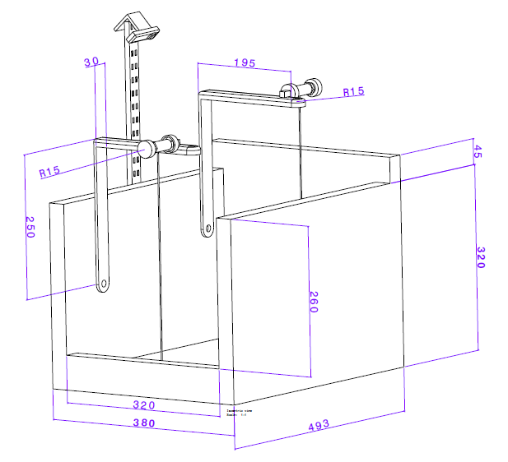

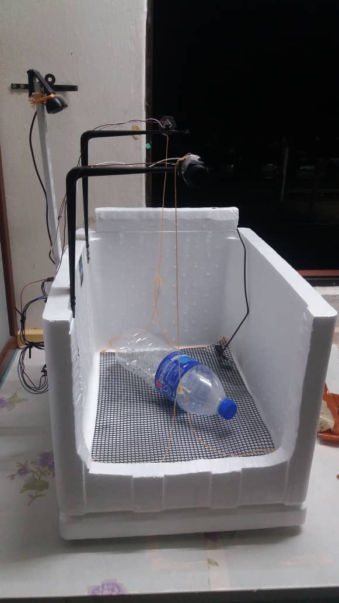

**5.2 Tools and Software Used**

**Hardware and Tools**

1) Arduino – A microcontroller that used to control the direction of the motor in our prototype

2) Maker Drive – Motor Driver that used to receive the control signal from the Arduino and then control the motor speed and direction.

2) Two 6V 85RPM DC Micro Metal Gearmotors – Motors that used to lift the net

3) Two 3.7V 18650 2000mAh Li-Ion Battery – Battery that used to power the motor

4) 18650 Battery Holder – Used to hold the 18650 battery

5) Polystyrene container – Used to store the water

6) 720p webcam – Used to detect the object in the polystyrene

7) Mosquito net – The net that will be lifted by the motor

**Software**

TensorFlow – A machine learning framework by Google

AutoCAD – Used to draw the design of the prototype

**Project Output**

|  |  |
| --- | --- |
| Type of Trash | Percentage of Trash Recognition (%) |
| Cosmetics | 47% |
| Bottle | 85% |
| Tin Can | 64% |
| Knife | 63% |
| Spoon | 93% |
| Fish | 94% |

**CONCLUSION**

**RECOMMENDATION**

**REFERENCES**

**APPENDICES**